# Poor Decision-Making or Cognitive Overload? Exploring Cognitive Load as a Mediating Factor Between Poverty and Child Maltreatment

**Maddie Brown, BSW and Ethan Kye, BSW University of Illinois Urbana-Champaign Abstract**

A complex relationship exists between poverty and child maltreatment, but the role cognitive load plays in this is often overlooked and misattributed to poor parenting and decision-making skills. Moreover, while current research has identified relationships between poverty, maltreatment, cognitive load, and stress, it has yet to explore this with an intersectional lens. This study addresses this gap by exploring cognitive load as a mediating factor between poverty and child maltreatment. Research lacks a universal measurement of cognitive load, but related factors including impulsivity, stress, and allostatic load can be used. These factors were measured using quantitative and qualitative data from families participating in the Empower Parenting with Resources (EmPwR) study, which examines the impact of unconditional cash gifts on families receiving intact services throughout Illinois. Arguably, the cognitive load experienced by families living in poverty affects their parenting practices, contributing to the risk of maltreatment. Thus, it is hypothesized that families who receive cash gifts will experience a decrease in cognitive load, subsequently decreasing child maltreatment. This study highlights how reducing cognitive load can enhance a family’s well-being and decision-making capacity, providing crucial insight into policy and program development.

*Keywords:* cognitive load, child maltreatment, poverty, stress

**About the Authors:** *Maddie* graduated in May 2025 with a bachelor’s degree in Social Work and a minor in Child Health and Well-Being. As a research assistant for the EmPwR study, Maddie is passionate about the role of research and advocacy in promoting social change. Her interests focus on child and family welfare.

*Ethan* graduated in May 2025 with a bachelor’s degree in Social Work. His research interests include mental health, poverty, and adolescents.

*These findings were presented at the 2025 Undergraduate Research Symposium and received the outstanding oral presentation award. All questions should be addressed to Maddie Brown, Empower Parenting with Resources Laboratory, University of Illinois Urbana-Champaign, 1010*

*W. Nevada St, Urbana, IL 61801. Email:* [*mbrown17@illinois.edu*](mailto:mbrown17@illinois.edu)

*Note: Additional contributors include Dr. William Schneider (Principal Investigator, EmPwR) & Alexis Krones (Project Director, EmPwR).*

# Introduction

Imagine being faced with an impossible dilemma: go to work and leave your child home alone because you cannot afford childcare or miss work and risk losing your income.

Unfortunately, this is the reality for countless families, especially those experiencing economic hardship. Yet, when families face such dilemmas, society often responds with judgment, questioning their parenting or reporting them to child protective services, rather than acknowledging the difficulty of these circumstances. These responses minimize the cause of child maltreatment to poor parenting skills and fail to consider the cognitive strain caused by economic hardship and how this impacts families. This prompts the research question: How does cognitive load mediate the relationship between poverty and child maltreatment? Thus, this study aims to explore the connection between poverty, cognitive load, and parenting, analyze how cognitive load influences child welfare outcomes, and contribute new insights to the literature on cognitive load theory.

# Literature Review

Cognitive load theory was first introduced by John Sweller in 1988 and posits that the mind has limited information processing capacity (Ball et al., 2023). According to the dual systems theory, when this capacity is exceeded, the reasoning system is compromised, and individuals rely more on the automatic and intuitive responses of system one thinking, rather than the slow and reflective reasoning of system two. As a result, individuals are more prone to rapid, impulsive, and emotion-based decisions (Zucchelli et al., 2025). It is important to note that cognitive load theory is primarily used for educational purposes to maximize learning and ensure students are not overloaded with more information than they can process. However, this theory applies to other areas, especially parenting and decision-making. While this concept remains

largely unstudied, cognitive load theory helps explain how parents experiencing cognitive overload might struggle to regulate their emotional responses or consider the long-term impact of their actions, which increases the risk of child maltreatment occurring.

Although existing literature has often overlooked this connection between cognitive overload and child maltreatment, meta-analyses confirm that poverty conditions increase the risk of maltreatment. Although this research does not explicitly use the term “cognitive load,” similar theories effectively capture the concept. For instance, the parental burnout theory describes how chronic stress and limited resources lead to emotional exhaustion and detachment from parenting. These burnout traits can result in neglectful or impulsive behaviors (Roskam et al., 2022). Similarly, the family stress model of economic hardship explains how financial strain heightens stress and emotional dysregulation, disrupts cognitive and emotional functioning, and increases the likelihood of harmful parenting (Kim et al., 2023).

Since the literature on this topic is limited, few standardized methods exist to measure cognitive load beyond task- and performance-based assessments, which are primarily used in educational settings and do not align with the goals of this study. However, as literature reviews show, other indicators can be used to quantify cognitive load. For example, poverty-related challenges such as financial stress, decision fatigue, and unemployment all increase cognitive load. Characteristics including impulsivity, stress level, and allostatic load can also be used to gain insights into a person's mental load.

# Methods

Data was drawn from the Empower Parenting with Resources (EmPwR) project; this IRB- reviewed study is the largest randomized controlled trial in the United States to examine the impact of monthly, unconditional cash gifts on child maltreatment and child welfare

involvement. Through unrestricted cash gifts, EmPwR aims to study how poverty-related stress affects parenting. The project, which began data collection in January 2025, will involve 800 families across Illinois who are receiving intact family services. Of these, 400 families will be randomized to receive monthly cash gifts over a 12-month period. The cash gift is scaled by family size and geographical cost of living, with an average monthly amount of $500. The remaining half of the families will receive services as usual, such as counseling, education, healthcare, transportation assistance, and other basic resources.

The EmPwR project utilizes several data sources, including quantitative surveys and qualitative interviews. The surveys align with this study’s research goals, exploring relevant areas including physical and mental health, socio-economic wellbeing, parental mastery, and family relationships. These surveys are offered to all consenting participants, and 49 have been completed since data collection began. In addition to surveys, the EmPwR study gathers qualitative information through individual interviews, gaining insights into participants’ family lives, interactions with child welfare systems, financial challenges, and day-to-day stressors. The EmPwR study will interview 60 participants, 40 in the treatment group and 20 in the control group; 25 interviews have been conducted thus far.

# Results

Preliminary findings from EmPwR's surveys show strong evidence of financial stress. For instance, 49% of participants surveyed were unemployed. Household income statistics also demonstrate economic hardship, with 48% of participants reporting a household income of less than $5,000, excluding other forms of financial assistance. In addition to high unemployment and low household income rates, 91% of participants reported having no savings, while the remaining 9% had between $175 and $5,000 saved. Also contributing to financial stress are the

high levels of debt many participants experience. Twenty-nine percent of participants reported being $5,000 to $15,000 in debt, and 12% were burdened by higher amounts ranging from

$25,000 to $80,000. As these statistics show, many individuals referred to intact services for reported child maltreatment are experiencing poverty-like conditions and a lack of resources, contributing to their cognitive load.

Survey instruments measuring common characteristics of cognitive overload, such as impulsivity, emotional reactivity, and increased mental and somatic stress symptoms, were analyzed to further this analysis. One instrument, the Perceived Stress Scale, analyzes how unpredictable, uncontrollable, and overloaded respondents find their lives. In this 9-item questionnaire, participants use a 5-point Likert scale to rate how often they experience specific stress-related feelings. Results showed a wide distribution of scores, with moderate stress levels occurring most frequently, and a noticeable number of participants showing high-stress scores (see Figure 1).

Another key characteristic of cognitive overload is impulsiveness. Impulsivity was measured using an abbreviated form of the Dickman Impulsivity Inventory, in which participants answered six questions on a 5-point Likert scale. As Figure 2 illustrates, survey data showed variance in impulsivity levels, with most participants demonstrating moderate-to-high impulsivity scores, suggesting there may be a relationship between stress and impulsivity.

The EmPwR survey also evaluated participants' allostatic load, which refers to the cumulative wear and tear on the body caused by chronic stress. Allostatic load was assessed using the Psychosocial Index, which consists of five subscales measuring stress, well-being, psychological distress, abnormal illness behavior, and quality of life. Using a combination of binary indicators and a 4-point Likert scale, participants’ total allostatic load was scored. As

shown in Figure 3, most participants had low allostatic load scores. However, a cluster of participants demonstrated very high cumulative stress, which is concerning and will be important to monitor as the sample size increases.

Similar findings emerge in EmPwR’s qualitative interviews. For example, Taylor1, a single mother of two daughters ages 11 and 17, detailed numerous challenges, including a complex history of domestic violence and financial instability. She constantly juggles multiple jobs, childcare issues, and an unreliable vehicle. Taylor expressed during the interview, "I feel like my brain is overloaded with things that I'm constantly trying to take care of, that I don't always have the means to take care of. It seems like there's always an obstacle and it's always somewhat out of reach for me" (T. Smith, personal communication, March 14, 2025). Taylor's description of feeling “overloaded” by unrelenting work, childcare, transportation, and financial strains, shows how poverty can overwhelm a parent’s mental capacity. As demonstrated by existing literature, these cognitive burdens can weaken planning, emotional regulation, and reflective parenting skills, which suggests it is not intentional neglect, but an overwhelmed mind that mediates the link between poverty and child maltreatment.

The experiences of another participant, Megan, also highlight how poverty-related stress impacts families. Megan, a mother of two boys ages four and eight, experienced the traumatic death of her daughter six years ago, which led to financial struggles and involvement with the Illinois Department of Children and Family Services (DCFS). Throughout the interview, Megan illustrated how financial stress, lack of childcare options, and fear of child removal have created a state of cognitive overload that directly affects her parenting. Megan stated, “I’m so worried about them being taken away from me forever that I can’t enjoy the time that I have with them”

1 All names are pseudonyms

(M. Lee, personal communication, March 27, 2025). Megan’s experiences highlight how stressors such as financial instability and child welfare involvement contribute to a cognitive state of emotional dysregulation and reduced parenting capacity, which increases the risk of child maltreatment.

# Discussion

While research findings suggest that cognitive load may mediate the relationship between poverty and child maltreatment, it is important to acknowledge that these are preliminary results based on a small sample size, which limits their generalizability. Additionally, the surveys and interviews rely on self-reports, which have a higher risk of inaccuracy due to memory limitations and the social desirability bias, as participants may respond differently based on how they wish to be perceived. Finally, since the survey was self-administered, factors such as reading levels and misinterpretation of questions could also affect data quality.

Considering these limitations, the EmPwR study will continue to consent, survey, and interview new participants until the sample size reaches 800. Follow-up surveys and interviews will also be conducted six and 12 months after participants’ initial consent. As the EmPwR project progresses, new data will be analyzed to determine the impact of unconditional cash gifts on participants’ cognitive load. Similar findings are expected, illustrating how cognitive load mediates the relationship between poverty and child maltreatment. Such results highlight the need for clinical interventions and policy changes to reduce cognitive burdens. This could include expanding mental health services and stress-reduction initiatives, reallocating resources in current child welfare programs, and, most importantly, increasing financial support specifically aimed at alleviating poverty.

# Figures

**Figure 1**

*Perceived Stress Scale*

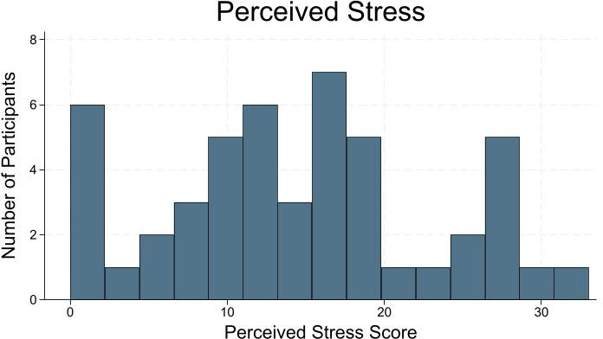

*Note*. α = 0.9182, see Appendix A

# Figure 2

*Dickman Impulsivity Inventory*

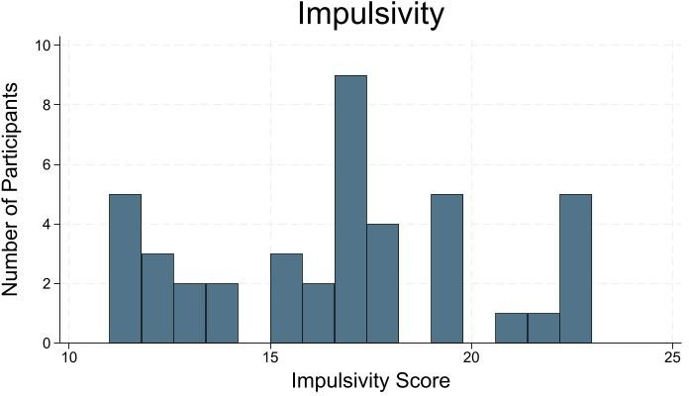

*Note*. α = 0.8756, see Appendix B

# Figure 3

*Psychosocial Index*

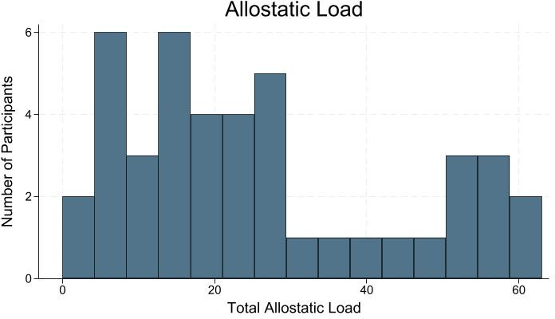

*Note*. α = 0.9336, see Appendix C

# References

Ball, S., Katz, B., Li, F., & Smith, A. (2023). The effect of cognitive load on economic decision- making: a replication attempt. *Journal of Economic Behavior & Organization, 210*, 226-

242. https://doi.org/10.1016/j.jebo.2023.03.018.

Edin, K., Waldfogel, J., & Haskins, A. (n.d.). Future of Families and Child Wellbeing Study.

Retrieved on October 23, 2024, from [https://ffcws.princeton.edu/.](https://ffcws.princeton.edu/)

Kim, J., Chung, Y., & Ahn, H. (2023). Poverty and child maltreatment: a systematic review.

*Journal of Public Child Welfare, 18*(4), 882–914. https://doi- org.proxy2.library.illinois.edu/10.1080/15548732.2023.2264819.

Magnuson, K., & Noble, K. (n.d.). Baby’s First Years. Retrieved on October 23, 2024, from [https://www.babysfirstyears.com/.](https://www.babysfirstyears.com/)

Piolanti, A., Offidani, E., Guidi, J., Gostoli, S., Fava, G. A., & Sonino, N. (2016). Use of the Psychosocial Index: A Sensitive Tool in Research and Practice. *Psychotherapy and Psychosomatics, 85*(6), 337-345. https://doi.org/10.1159/000447760.

Roskam, I., Vancorenland, S., Avalosse, H., & Mikolajczak, M. (2022). The missing link between poverty and child maltreatment: Parental burnout. *Child Abuse & Neglect, 134,* 105908. https://doi.org/10.1016/j.chiabu.2022.105908.

Zucchelli, M., Trotti, N., Pavan, A., Piccardi, L., & Nori, R. (2025). The Dual Process model: the effect of cognitive load on the ascription of intentionality. *Frontiers in Psychology, 16*. https://doi.org/10.3389/fpsyg.2025.1451590.

# Appendix A Perceived Stress Scale

The Perceived Stress Scale used in the EmPwR survey was developed by Magnuson and Noble (n.d.). Respondents are asked how often the following items occurred in the last month, using a 5-point Likert scale of Never (0) Almost Never (1) Sometimes (2) Fairly Often (3) and Very Often (4). Items are summed, with questions four and seven reverse coded. Higher scores indicate higher perceived stress.

1. Been upset because of something that happened unexpectedly?
2. Felt that you were unable to control the important things in your life?
3. Felt nervous and "stressed"?
4. Felt confident about your ability to handle your personal problems?
5. Found that you could not cope with all the thinking that you had to do?
6. Been unable to control irritations in your life?
7. Felt that you were on top of things?
8. Been angered because of things that were outside of your control?
9. Felt difficulties were piling up so high that you could not overcome them?

# Appendix B

**Dickman Impulsivity Inventory**

The EmPwR survey utilizes an abbreviated form of the Dickman Impulsivity Inventory, as used by Edin et al. (n.d.). Respondents are asked to rate how much they agree with the following statements on a 4-point Likert scale of strongly agree (1), agree (2), disagree (3), and strongly disagree (4). The items are then summed and reverse-scored, with higher values indicating higher impulsivity.

1. I will often say whatever comes into my head without thinking first.
2. Often, I don't spend enough time thinking over a situation before I act.
3. I often say and do things without considering the consequences.
4. I often get into trouble because I don't think before I act.
5. Many times, the plans I make don't work out because I haven't gone over them carefully enough in advance.
6. I often make up my mind without taking the time to consider the situation from all angles.

# Appendix C Psychosocial Index

The Psychosocial Index, used to measure participants’ allostatic load, was referenced from Piolanti et al. (2016). Questions are organized into five subscales and scored as detailed below. All scores were then summed, with higher values indicating higher allostatic load.

* + Stress: the scale includes 15 Yes/No questions (1-2G). “Yes” is scored as 1 while “No” equals 0, with question 2A reverse scored.
  + Well-Being: the scale includes 6 Yes/No questions (2H-2M). In questions 2J-2M, “Yes” is scored as 1, while “No” equals 0; questions 2H-2I are reverse scored.
  + Psychological Distress: the scale includes 15 questions (3A-3O) on a 4-point Likert scale of not at all (0) only a little (1) somewhat (2) and a great deal (3).
  + Abnormal Illness Behavior: the scale includes 3 questions (3P-3R) on a 4-point Likert scale of not at all (0) only a little (1) somewhat (2) and a great deal (3).
  + Quality of Life: includes question 4 and has 5 answer choices of excellent (0) good (1) fair (2) poor (3) and awful (4).

1. Did any of the following happen to you in the past year? (Yes/No):
   1. Death of a family member or close friend.
   2. Separation from long-time partner.
   3. Recent change of school or job.
   4. Financial difficulties.
   5. Moving within the same city.
   6. Moving to another city.
   7. Legal problems
   8. Beginning of a new relationship.
2. Please answer the following questions (Yes/No):
   1. Are you satisfied with your studies or work?
   2. Do you feel under pressure at school or work?
   3. Do you have problems with your schoolmates or colleagues at work?
   4. Do you have serious arguments with close relatives?
   5. Has any close relative been seriously ill in the past year?
   6. Do you feel tension at home?
   7. Do you feel lonely?
   8. Do you have anyone whom you can trust and confide in?
   9. Do you get along well with people?
   10. Do you often feel overwhelmed by the demands of everyday life?
   11. Do you often feel you cannot make it?
   12. Do you tend to be influenced by people with strong opinions?
   13. Do you tend to worry about what other people think of you?
3. Please describe any problems or difficulties you have had recently and indicate how much they have troubled you by marking the appropriate column.
   1. It takes a long time to fall asleep
   2. Restless sleep
   3. Waking too early and not being able to fall asleep again
   4. Feeling tired on waking up
   5. Stomach, bowel pains
   6. Heart beating quickly or strongly without a reason
   7. Feeling dizzy or faint
   8. Feelings of pressure or tightness in head or body
   9. Breathing difficulties or feeling of not having enough air
   10. Feeling tired or lack of energy
   11. Irritable
   12. Sad or depressed
   13. Feeling tense or ‘wound up’
   14. Lost interests in most things
   15. Attacks of panic
   16. Do you believe you have a physical disease but that doctors have not diagnosed it correctly?
   17. When you read or hear about an illness, do you get similar symptoms?
   18. When you notice a sensation in your body, do you find it difficult to think of something else?
4. How do you rate the quality of your life? (Excellent, Good, Fair, Poor, Awful)